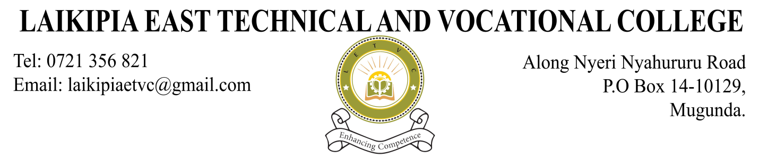

**SCHEMES OF WORK**

COLLEGE: LAIKIPIA EAST TVC MODULE: CICT Mod II SUBJECT: COMPUTER MAINTENCE AND SUPPORT

DATE: 07/05/2024 TERM: TERM 1 CLASS: CICT /J/23 TRAINER’S NAME: DUNCAN NDEGWA

|  |  |  |  |  |  |  |
| --- | --- | --- | --- | --- | --- | --- |
| **TERM 1** | | | | | | |
| **Week** | **Topic/Lesson Title** | **Objectives** | **Key Points** | **Activities** | **Reference & Aids** | **Remarks/**  **Date Taught** |
|  | **REPORTING AND REGISTRATION** | | | | | |
|  | Introduction to computer Maintenance | By the end of the lesson the leaner should be able to:   * Define computer terminologies * Outline computer hardware components * Describe computer maintenance tools and equipment | * Definition * Computer hardware components * Maintenance tools | Taking notes  Practical session  Class discussion  Questions and answers | * Graves, M. (2001). *PC Hardware Maintenance and Repair*. Prompt Publications. * E-books |  |
|  | Maintenance | By the end of the lesson the leaner should be able to:   * Explain maintenance concepts * Discuss computer cleaning materials | * Maintenance concepts * Cleaning detergents | Taking notes  Practical session  Class discussion  Questions and answers | * Graves, M. (2001). *PC Hardware Maintenance and Repair*. Prompt Publications. * E-books |  |
|  | Computer input and output devices | By the end of the lesson the leaner should be able to:   * Describe I/O Device operations * Describe Types of I/O ports | * I/O Device operations * Types of I/O ports | Taking notes  Practical session  Class discussion  Questions and answers | * Graves, M. (2001). *PC Hardware Maintenance and Repair*. Prompt Publications. * E-books |  |
|  | Motherboard and Buses | By the end of the lesson the leaner should be able to:   * Identify motherboard components * Describe motherboard form factors * Identify system buses * Outline procedure of installing a computer motherboard | * Components * Form factors * System buses | Taking notes  Practical session  Class discussion  Questions and answers | * Graves, M. (2001). *PC Hardware Maintenance and Repair*. Prompt Publications. * E-books |  |
|  | Processors | By the end of the lesson the leaner should be able to:   * Trace processor evolution * Outline processor characteristics * Describe processor slot types | * Characteristics * Processor slots | Taking notes  Practical session  Class discussion  Questions and answers | * Graves, M. (2001). *PC Hardware Maintenance and Repair*. Prompt Publications. * E-books |  |
|  | Memory | By the end of the lesson the leaner should be able to:   * Explain characteristics of memory * Types of memories * Describe RAM technologies   Distingush between BIOS and CMOS | * Characteristics * Types * RAM Technologies | Taking notes  Practical session  Class discussion  Questions and answers | * E-books * Graves, M. (2001). *PC Hardware Maintenance and Repair*. Prompt Publications. |  |
|  | **CAT ONE AND ASSIGNMENT 1** | | | | |  |
|  | Storage | By the end of the lesson the leaner should be able to:   * Describe the types of disks and drives * Explain disk management techniques * Compare hard disk interfaces | * Types * Disk management techniques * Hard disk interfaces | Taking notes  Practical session  Class discussion  Questions and answers | * E-books * Graves, M. (2001). *PC Hardware Maintenance and Repair*. Prompt Publications. |  |
|  | Power Supply | By the end of the lesson the leaner should be able to:   * Outline the importance of power supply * Explain power supply form factors and connectors * Explain power supply problems * Explain power supply problems * Explain the power supply protection devices | * Functions * Form Factors * Power supply problems * Protection devices | Taking notes  Practical session  Class discussion  Questions and answers | * E-books * Graves, M. (2001). *PC Hardware Maintenance and Repair*. Prompt Publications. |  |
|  | Computer Assembly and Disassembly | By the end of the lesson the leaner should be able to:   * Describe hardware inventory * Outline assembly and disassembly features * Explain computer upgrading | * Procedures * Computer upgrading * Inventory | Taking notes  Demonstration  Class discussion  Questions and answers | * E-books * Graves, M. (2001). *PC Hardware Maintenance and Repair*. Prompt Publications. |  |
|  | **REVISION AND EXAMINATIONS** | | | | | |

Trainers Sign…………………. HOD’s Name....................………...Sign and stamp…………… Date………….